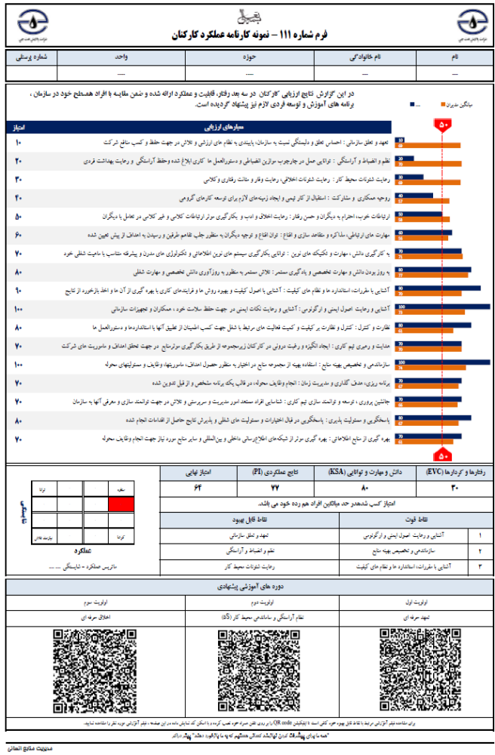
کد: HRM-J-FM-35-00

